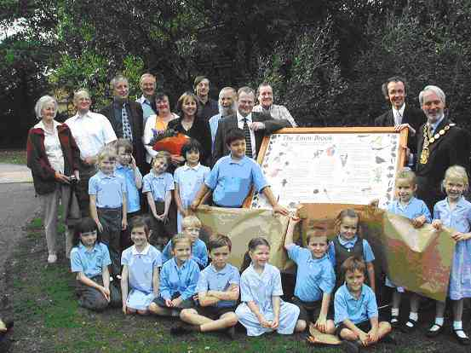

First Information Board on the Emm Brook
A project by The Hawthorns Primary School for FOTEB led by Stephanie McKay.

It all began in 2005 when I won an environmental award for an idea I had to work with the children in my class on a project to improve our local area. The children wanted to provide information about wildlife and habitats around the Emm Brook that would be of interest to passers by. Perhaps I should add that I am both a local resident and a teacher at The Hawthorns School. FOTEB came along just at the right time for me and the organisation gave me the support I needed to raise funds for the information board.

The children began their project in the third term of the Reception Year and it took almost 18 months to complete. We began with a summer walk to the Emm Brook and learnt about the importance of camouflage for the survival of small creatures such as caterpillars. Work continued into Year 1 when the children visited the brook again in the autumn and in the winter. In the autumn we collected leaves and looked at the different trees growing on the banks of the brook. In the winter it was cold but the children all wrapped up and took Pooh Sticks to drop from one of the bridges. We were investigating in which direction the water flowed.

Back in school we learnt about the kingfisher and painted pictures of the wildlife that lives in and around the brook. The leaves from our autumn walk were pressed and used by the children to design a repeating pattern to decorate the border of the information board. The children were very keen to point out how dangerous water could be and felt there should be some sort of safety warning on the board. Their ideas were developed through literacy work into the Emm Brook Code modelled on the Countryside Code. Friends of the Emm Brook were a great help in contributing botanical, geographical and historical information. Many thanks to Robert Shelley of Shelley Signs for the design and manufacture of the board!

We picked a warm sunny afternoon on Wednesday 27th September for the unveiling of our board on Riverside Walk behind Morrisons supermarket. Mr Allan, M.D of CALA Homes, and Cllr Angus Ross, Chairman of Wokingham District Council cut string while two children pulled back the paper to reveal their hard work. Everyone present was totally delighted with the new board. Unfortunately, as you may be aware, the board was vandalised and the next day it was found in the brook. We were all very disappointed and are looking forward to the board being on view once again. The information board will now be fixed to a stronger base and should be available for public viewing in November.
- Editor : FOTEB thanks Andy Glencross and the team at Dinton for all their help and the board is now back in all its splendour, bolted to a huge tree trunk. Thank you Stephanie for such a wonderful contribution to FOTEB.
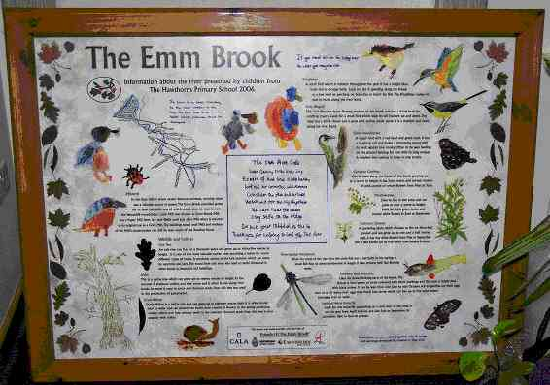
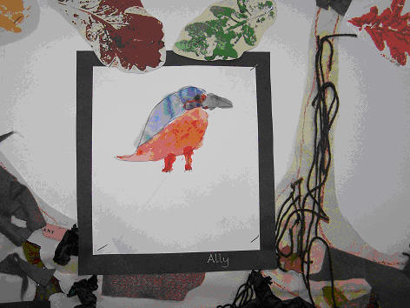
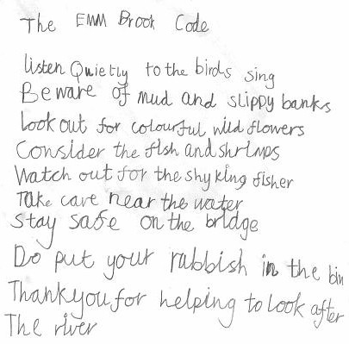
The Information Board

AGM May 2006
The AGM was held at the Woosehill Community Hall and well attended. After the formalities had been completed we heard a very interesting talk by Alex Hazel of the Environment Agency who helped us understand the responsibilities and work of the Agency, especially the water quality monitoring they undertake. We were pleased that the Emm Brook rates a ‘B’, which indicates a healthy river. We hope to keep it that way with your help and interest. Paul Bright-Thomas provided feedback on the bird survey that had been carried out during 2005. See the kick sampling survey report to see how we are extending the work of the Agency locally.

Nightjars – by Cyril Fuller
I usually try each summer to visit a site known for its Nightjars, so this year we decided that we would go to Gorrick Woods (where there is a feeder stream for the Emm Brook). We arrived as it was getting dark, about 9.30pm. Having wandered around we decided there were at least three pairs nesting in the area. We heard at least three birds churring and a possible fourth. We saw
two birds in flight over our heads and the white wing patches were clearly visible. The churring can be an eerie sound if you've not heard it before, all part of a summer’s night. On the way home we spotted two Glow-worms. An evening well spent.

Whilst walking round for my FOTEB bird survey I chanced to see the rear end of a deer disappear into the undergrowth not fifty yards from the Finchampstead Road!

Emmbrook Mill
At the public meeting in January Colin Mitchell and Jack Earnshaw had researched and presented information on the Mills on the Emm. Excitingly, this has resulted in two photos of the Little Mill being offered by Brian Eighteen - see our web site.

Information Leaflet
Stephanie and Roland produced a leaflet that introduces FOTEB to the public. Copies of the leaflet are available from the library, town hall information centre, the Chairman and our web site. Well done and thank you.

Ancient trees along the Emm Brook
An attractive feature of the Emm Brook is the great variety of trees and shrubs along its banks and on land nearby. Some of these grow alongside public footpaths and open space but many flourish in the private gardens, which back on to the river.

All of these trees and shrubs are beautiful in their own right but they also provide a rich habitat for a variety of wildlife including small mammals, birds and insects. Of especial importance for wildlife are the really old trees, which are home to many of the species of fungi, lichen and insects only to be found on ancient trees.

Recently four Friends of the Emm Brook surveyed the veteran trees along the Riverside section of the Emm Brook, from Barkham Road to the Woosehill roundabout. Veteran trees are those whose trunks are over 1 metre in diameter (a girth of over 3m) at 1.5 metres above the ground. The surveyors found 35 trees of this size and many more, nearly that size - all veterans of the future.

Of the 35 existing veterans, 23 are oaks and 7 are very fine decorative weeping willows near Barkham and Meadow Roads. Downstream there are a number of crack willows, often pollarded in the past for agricultural use, and of these 3 are over 3m in girth. There is also a very large ash and an alder near the weir by the Woosehill roundabout.

The FOTEB veteran tree team hope to survey other sections of the Emm Brook. If you are interested to know more or to help please contact Barbara Stagles on 0118 9784013 or bkstagles@btinternet.com .

Balsam Pulling – by Sue Farrington
In June and July stalwart members of FOTEB undertook the task of trying to rid one section of the Emm Brook of the invasive flowering plant Himalayan Balsam. Despite its beautiful pink and white flowers this introduced species is smothering our native waterside plants. If we lose the native plants, we shall lose the insects, their grubs and then the birds and fish that depend on them. How sad it would be to end up with just one plant type and no other wildlife. Our conservation effort involved us in wading along the Emm beside The Emmbrook School for 3 sessions of about two hours each. It was hard work but also fun and we cleared the section of all that we could reach. The recommendation is that we repeat this for about three years, which will hopefully diminish the Balsam.
You may have noticed the plant in other parts and some of our members have done a great job in pulling it out in their areas. If you have it in your garden do please remove it (you can compost it if you can pull it out before the seed sets).
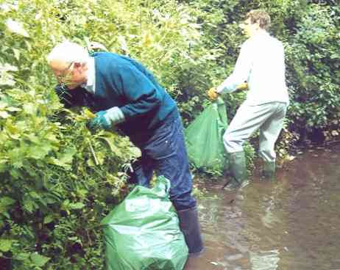

Emmbrook Walk – by Robert Vacher
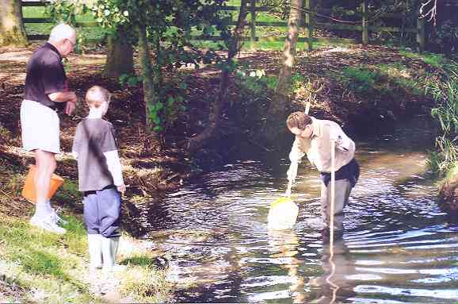
Earlier this year the Environment Agency carried out some work on the Emmbrook just upstream of the Old Forest Road bridge. One task that was tackled was to remove part of a willow tree, which was blocking the flow of water by collecting water-borne debris. At about the same time the section of brook between the tree and the road bridge was dredged with silt and vegetation being removed. When members of the Friends of the Emmbrook carried out kick-sampling in this section of the water they found there was a difference between creatures living in the dredged and non-dredged parts. Like people, these creatures also seem to move to live in their preferred environment! Other work carried out in the fields of the Emmbrook Walk during the past year include improving the access ramps to the two footbridges and removing a section of brambles and undergrowth which had developed along the brook causing the water to have become “invisible” from the field.

Kick Sampling – by Mike Saynor
On 24th September about 20 people helped take and examine ‘kick samples’ from the Emm. We had an enjoyable time and learnt a lot about the wildlife in the river - and very few of us got wet!

Biologists use the ‘kick sampling’ technique to assess the numbers and types of invertebrates present in rivers and streams. From this they can tell much about the general quality of the water, and after pollution incidents they can assess the extent of the problem and measure how quickly rivers recover. We took our samples immediately up-stream from the bridge over the Emm on Old Forest Road. Here, every three or four years in the spring and autumn, the Environment Agency (EA) takes similar samples. The EA now has information covering at least 20 years and in due course, once Members are more proficient at identification, FOTEB hopes to add to this pool of information.

Samples are collected using a standard method of three minutes active sampling with a pond net. The sampler stands up-stream of the net and moves one foot vigorously backwards and forwards across the river bed. This dislodges the invertebrates present, which are then caught in the net. A number of such ‘kick samples’ are taken across the river to get a representative sample.

Bob Loades, kitted out in waders, and with a stout shepherd’s crook for additional support, took the samples, which were tipped into buckets and then white trays for examination and counting by everybody. Small specimens were examined under a microscope or with hand lenses, and identified with pictorial keys and reference books. Samples of the commonest and the more interesting specimens were also kept for future reference. We identified invertebrates from four phyla, but arthropods - crustaceans, mites and insects, were by far the most numerous. We caught three small fish, a bullhead, a three-spined stickleback and an unidentified specimen, probably the fry of a larger species.

Small animals are always much more interesting when they are magnified and folk were fascinated by the fierce looking dragonfly and damsel fly nymphs, the very active water beetles, mites and alder fly larvae, with their delicate feathery gills, through which they breathe in the muddy bottom of rivers and ponds. Perhaps the most fascinating and numerous insects were the cased caddis fly larvae which, until they started to move, were indistinguishable from tiny twigs!

Regrettably we were unable to identify all the animals we found, but we hope to become more proficient and plan to sample again in the spring, probably in April or May. If you came in September, please come again, and newcomers you are most welcome, whether you know a lot, a little or nothing about fresh water invertebrates. Experts though, would be particularly welcome!

We need a new editor for this Newsletter!!!!!!!
Please contact the chairman (0118 978 2371) if you can help. We only need 3-4 issues a year, based on the activities of FOTEB.

